Hang the man

# Project description

Game idea:

The program is going to be a console application.

The user will have to guess a random word, before he runs out of life.

Main menu:

The game starts in a main menu where you can do two things:

!rules

* Explains the rules about the game

!start

* Starts the game

!credit

* Shows credit

Life:

The user have a certain amount of life, everyone time the user guess a letter that is not in the word he is going to lose a life. The letter goes into an array so the user cannot use that letter again.

If the user guess right, the word will be filed with that letter where it needs to go.

When the life counter hits zero you will lose the game.

# Motivation

I like to make small game and something like hang the man, is something all we like and I have made it before, but not with the help from Multi-Thread, Delegate, Interface or Inheritance.

Multi-Thread:

I want a thread to art as a timer so when the user wins or dies, he can see how much time he used on that level.

There will also be a thread to manage the arrays we have in the program, so one thread to find the random word the user must guess. Another thread to add the used letters to the list.

Delegate:

I am going to use delegate to keep control of the threads and how they are working, and do so some things will not run before another thread has done its thing.

Interface:

I have some class’s that is going do basically the same, so I’m going to use an interface to save some space in the code, and to make it easier to change if you want to change something at a later point.

Inheritance:

I want to make it easy to call and change a variable and inheritance is the best way to do that, as when the user lose a life it will be easy to change.

UML Before:

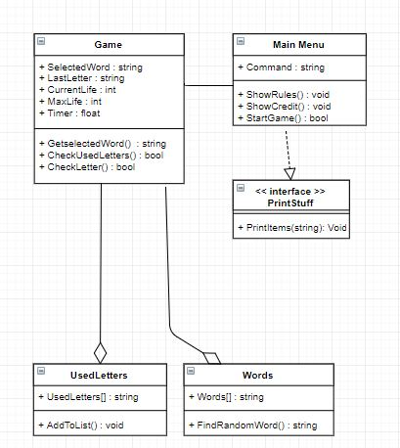

# After:

# C:\Users\Richard Brown Thomse\AppData\Local\Microsoft\Windows\INetCache\Content.Word\UML After.jpg